* **Install and start service**

1. Launch CMD and run as administrator.

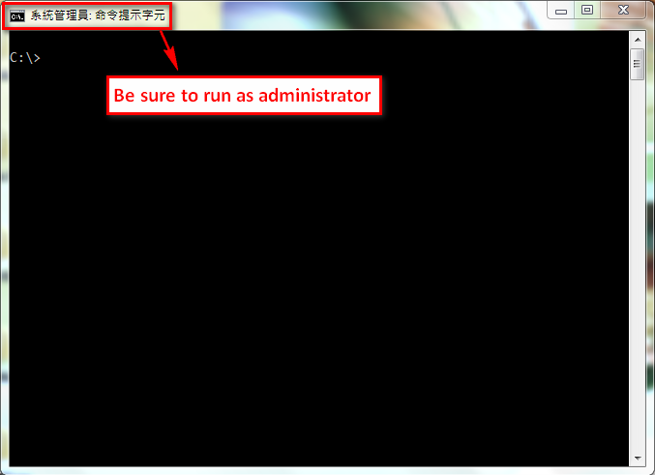

2. Go to “..\Service” directory.

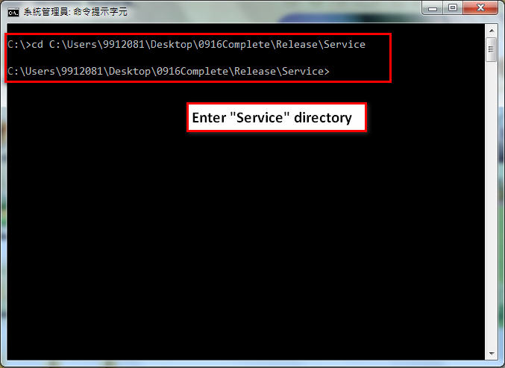

3. Execute **InstallService.bat**

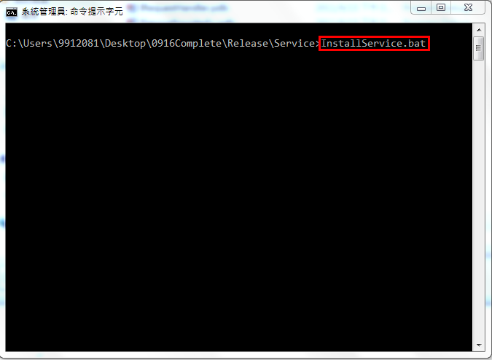

4. Complete install and start the service: “**AutoFlow Service Controller**”.

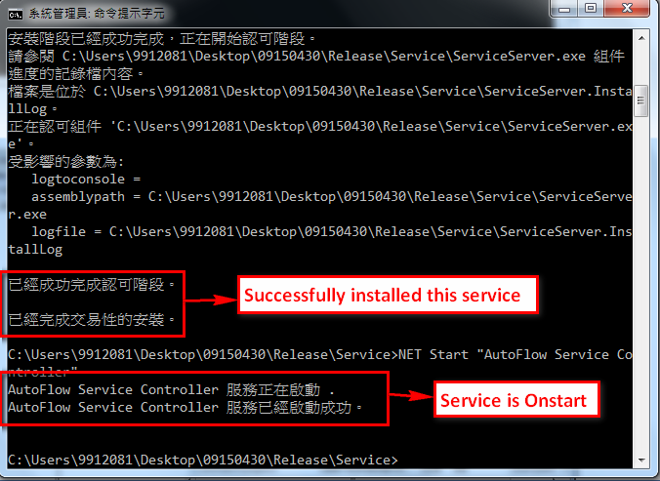

5. Check the service’s working state.

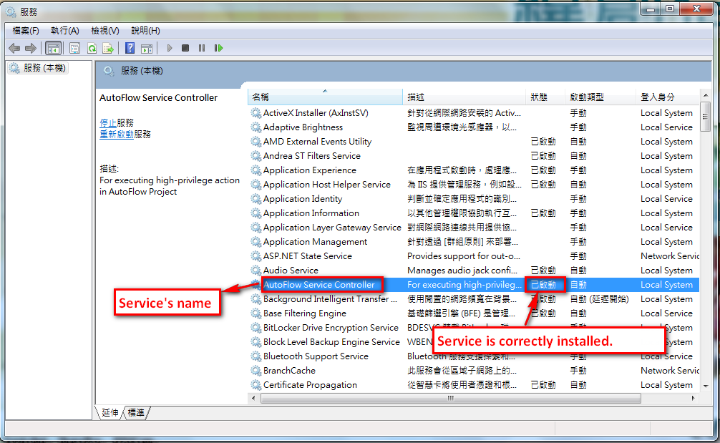

* **Stop and Uninstall Service**

1. Launch CMD and run as administrator.



2. Go to “..\Service” directory.



3. Execute **UninstallService.bat**

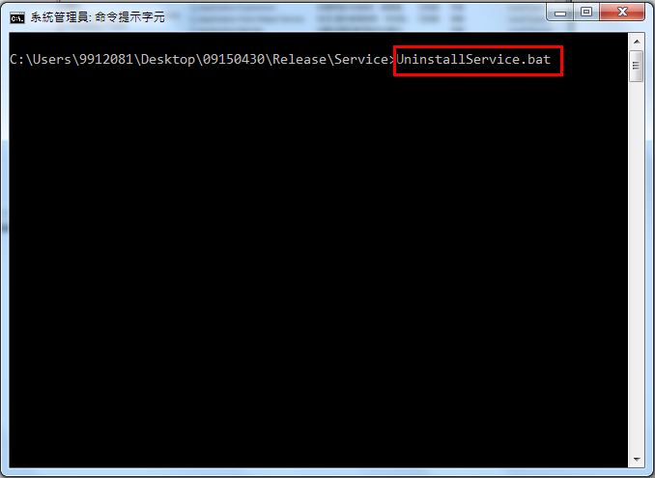

4. Complete uninstall service

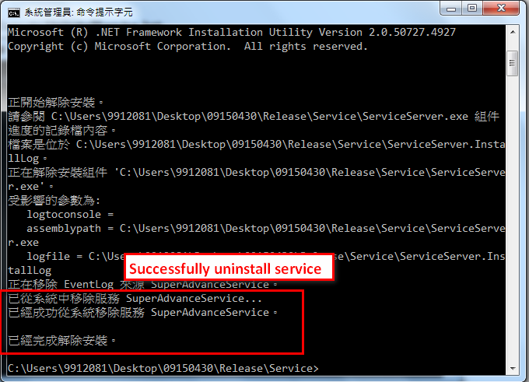

5. Check the service is uninstalled completely.

